So Much More!

The Vale Pantry Impact 2023

The Vale Pantry works with the most financially disadvantaged families throughout North Dorset. Providing a range of fresh, chilled, frozen, and ambient foods is where the work starts. Uncovering the causes that have led to food poverty gives us the opportunity to provide help, support, interventions, and mentoring to get people back on their feet again.

Since opening in November 2020, more than 750 families' lives have been improved through our membership to The Vale Pantry an independent Pantry which started under the Your Local Pantry Network. Put simply we soften the blow of high living costs and create the conditions for our community to grow and thrive, by bringing people together around food. We work to foster friendships, loosen the grip of poverty, and contribute to healthier, happier lives. We operate as a membership food club and neighbourhood hub, often serving as springboards to other community initiatives, opportunities, and ideas.

In early 2023, Your Local Pantry undertook research with their Pantry members and Coordinators for their social impact report. Led by researchers Sarah Purcell, Fiona Tweedie, and Jane Perry, this research sought to listen, explore, and understand the difference being a member of a Pantry has made to households across the UK, through a members' survey, a Pantry survey, economic analysis and listening to the stories of members. Here we share what we learned about the difference being a member of our Pantry has made to our members. The full Your Local Pantry social impact report is available at www.yourlocalpantry.co.uk/social-impact-reports

What our members say …

Why is being a member important to you?

‘It's the extra support and help that they offer when you feel you are really stuck.’

‘[It] alleviates the stress of not having enough money for food.’

‘The emotional support which I get, and how the Pantry is helping to tackle isolation.’

‘It is a life saver and when I visit it feels like a big family. The ladies are all so nice, helpful and caring.’

‘We literally wouldn’t eat if it wasn’t for the Pantry. They also help out with lots of things, so if I’m in a rut with something I know I can always ask them about what to do.’

‘It gives me a chance to afford better quality food (nutritional value, variety etc.) than I would be able to otherwise.’

Key Figures

How many households are current members? (as of the end of August 2023)

372 households made up of 1,016 people
Adults: 597 & Children: 419

- Weekly fee for membership: £7

- Potential saving each visit: £30

- Annual total saving: £1,560

- 20,558 visits since we opened in 2020

Since opening in November 2020 over 390 Households have been helped and supported back to independence, through our various strategies and one-to-one mentoring & help.

Key Figures Accurate in August 2023.

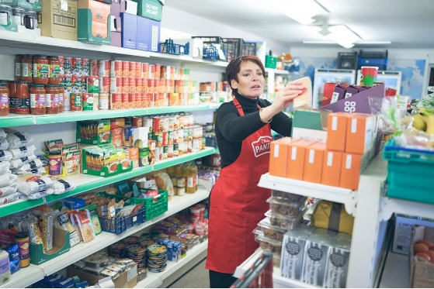

What our Members Say (%)

100% say being a member has improved their finances.

100% say tackling food waste was important to them.

81% feel more connected to their local community through the Pantry.

67% say being a member has improved their physical health.

88% say being a member has improved their mental health.

72% have made new friends at the Pantry.

49% say they are eating less processed food.

58% say they are eating more fresh fruit and vegetables.

15% Currently volunteer at the Pantry.

“Thank you so so much for your kindness and generosity to us all. I am blown over by the help I received this week, extra to the amazing work you do for us constantly. I have just put some pantry ingredients into my new slow cooker 🍁👍👍to make mushroom soup, it's wonderful and so big, will be great for batch cooking for the freezer. Please know how much we appreciate you and all you do, you really are wonderful, ⭐⭐⭐⭐⭐⭐⭐⭐⭐ thank you” Pantry Member

“Thank you for our lovely new oven. It's brilliant on electric so won't cost as much to use. And plenty big enough for us. In fact now we have it I'm not sure how we managed without one. You all do a great job and are very kind and caring. You have made a huge difference to our lives since we met you all, not only for food but for the friendship you have shown us. And support you have shown us. I can honestly say I look forward to coming to the pantry once a week to see you and feel surrounded by caring people”. Pantry Member

How does the Vale Pantry help members?
Our research found that we help members in a number of different ways, from saving money and helping people to put healthy food on the table, to improving mental health, breaking social isolation, making new friends and new community connections, accessing other types of support (e.g. advice on housing, welfare and debt), and for Pantry volunteers - gaining new skills and confidence, and importantly helping families and individuals back on their feet again and to independence. In 2022 The Vale Pantry assisted 128 families back on their feet, and from January – August a further 130 families have now been able to step back and stand on their own two feet again.

What our members said:
‘Without the pantry we would be eating very poorly and be in a lot more debt. The volunteers make my family and I feel so welcome and that we will be okay.’
‘I love the social aspect, being a carer for my mum I enjoy speaking to other adults.’
‘Feeling less anxious about money.’
‘I was depressed before coming to the pantry but now I feel part of something and I am not lonely. I have started to work again because my health has improved.’
‘I have learned new skills and improved my confidence.’
‘Good for my mental health and I enjoy help others in similar situations and giving advice.’
‘It is a happy time when we come home from Pantry and show our children what we got. They are always so excited. And happy when they get special fruits and meats.’
‘I can live. Not just try to survive.’
‘It’s saved our lives.’
‘They do not judge you . They are very kind and helpful .If it was not for them I do not know how we would cope. It stopped me from getting very depressed.’

The Vale Pantry provides the following help:
- Access to our dedicated Citizen’s Advisor who is able to provide 8 face to face appointments each week
- Budget Coaching
- Cookery Education and Menu Planning
- Children’s Activities such as Cookery Workshops, Summer Play and more
- Help with the provision of crisis goods
- Help with Children’s clothes and warm winter coats each Autumn
- Mentoring through times of crisis
- Transport to medical appointments, job centres and more
- Help for the frail and elderly with visits and food to include welfare checks
- Help with CV writing
- Advocating for our members with statutory agencies when needed

What do members do with the savings made by using the Pantry?
When members were asked what they did with the savings made by using the Pantry, they overwhelmingly said any money saved goes towards other household bills and expenses. Below are some quotes from members answering this question.

‘Spend money on bills.’
‘Repay debt I was struggling with.’
‘Helps with increased energy cost.’
‘Day’s out when we can.’
‘I use the money to travel to see my mum who is unwell.’
‘Paying for my children's competition.’
‘The money has helped with the extra on heating etc.’
‘Helps to not get into debt paying rent and other bills.’
‘There is no money left over.’
‘Took the worry and stress at buying food, now I can use it for the kids.’
‘Helps us treat ourselves. More before when couldn't at all.’

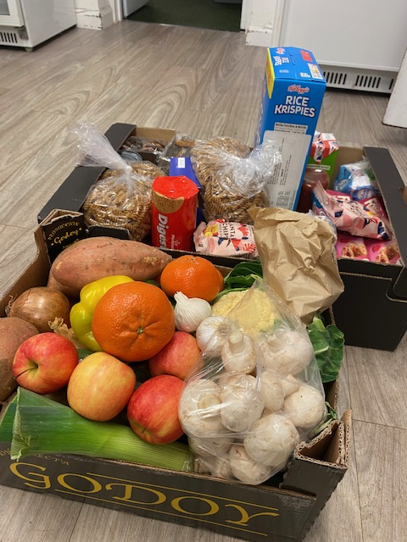
A typical Family Shop for a household, which a member will pay £7 for.

Pantry development story: The Vale Pantry, Dorset

The Vale Pantry is located in a rural area of Dorset, which is a new type of location compared to most Pantries that are located in towns and cities. Access to the nearest big supermarket involves a 25-mile round trip; around 15% of people in the local area do not have cars, rising to 34% of those living in social housing, and public transport is unreliable. People drive to the Pantry if they are able to and offer lifts to people who do not have transport. The Pantry now has their own van which they call ‘Pantry on Tour’ (pictured). The van goes out to people who can’t get to the Pantry itself.

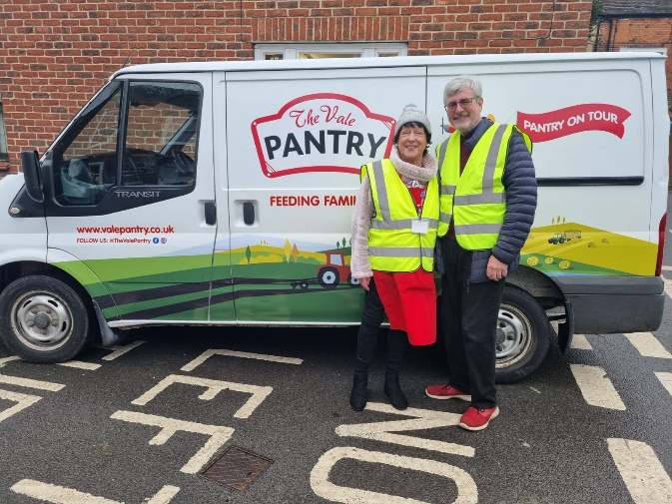
“People come to us or we go out to them.” Carole, founder and trustee, The Vale Pantry, Dorset
The Vale Pantry has its own Citizen’s Advice worker (working with the Pantry for 12 hours a week). Carole says the adviser is always busy, working with members to help them to ‘get back on their feet’, and aiming to change their circumstances for the better. The Vale Pantry run a variety of activities throughout the year, including a children’s cookery workshop in the school holidays, which teaches them to make a meal, from scratch, for their parents. They also run a support group for parents with autistic children.
The Pantry provides mentoring to members, and also works closely with Dorset Council children’s and adult’s services, the mental health team and local schools. The Pantry has worked with a range of people including people with life-limiting illnesses and homeless people (whom the Pantry has helped to find homes and employment).
Carole says that there are many stories of people who are in a much better place since joining the Pantry. Last year the Pantry secured funding to help people living with fibromyalgia; this enabled a group of people with the condition to access hydrotherapy once a week for six months. People from these groups made friends and continued to support each other. This summer the pantry has run to run a twelve-week health and wellness programme, including activities like outdoor yoga.
A local farm provides the Pantry with their excess fruit and vegetables, and in return, Vale Pantry has a scheme that gives members and their families the chance to spend some time helping at the farm during the growing season (watering, weeding, etc.) and enjoy a meal together at the end of the day.
“… And I just wanted to say a massive thank you to all of you for helping us this past year. We’re so proud. Rob has now passed his apprenticeship. We’ve really appreciated it from every vegetable to every pack of nappies. We hope the next family finds you as helpful as we did.” Vale Pantry member

As seen in the Daily Telegraph 24 August 2023
SIR- A growing number of Britain’s Food Banks are searching for an exit strategy that can prevent another decade of lengthening queues for, and growing dependency upon, emergency food parcels. One such strategy entails either adding on - or converting into - an affordable food club such as a pantry or social supermarket. Food banks in 30 towns and cities across our network have done this. Each has reported an immediate reduction in - and in some cases a total elimination of the need for emergency food parcels, as well as a transformation advance formation in residents' experiences of accessing the service.
They are members of a club rather than clients of a crisis service. They come to shop rather than be handed an emergency food parcel, and they choose from a wide range of fruit, vegetables, meat, fish and other fresh products. They access the service in return for a manageable contribution.
Crucially, this dignified and cooperative food offer is accompanied by advice and even credit union services to maximise incomes and address the root causes of poverty. Meanwhile, the social element is tackling the loneliness and isolation that poverty so cruelly imposes on people's lives.
This fundamental shift in frontline provision from food bank to food club must form a key component of any anti-hunger programme.
Andrew Forsey
National Director, Feeding Britain.

Contact us:
The Vale Pantry
35A Market Place, Sturminster Newton, DT10 1AR.
Tel. 07968 348481
Email: info@valepantry.co.uk

*Figures based on responses from members in the 2023 members’ survey.

